# **Sustainable Smart City Assistant Using IBM Granite LLM**

## **1. INTRODUCTION**

### **1.1 Project Overview**

The Sustainable Smart City Assistant is an intelligent modular platform that empowers urban governance, enhances sustainability, and fosters citizen engagement. Built on IBM Watsonx's Granite LLM, FastAPI, and Streamlit, it delivers features such as policy summarization, eco tips, anomaly detection, and predictive analytics—all accessible through a unified dashboard.

### **1.2 Purpose**

To simplify urban decision-making and promote proactive sustainability through AI-powered services, enabling city planners, citizens, and administrators to engage with structured and unstructured urban data more effectively.

## **2. IDEATION PHASE**

### **2.1 Problem Statement**

Cities lack a centralized AI interface that can help analyze urban KPIs, summarize complex policies, and support sustainable decision-making through citizen interaction and intelligent automation.

### **2.2 Empathy Map Canvas**

* **Think & Feel**: Urban planners feel overwhelmed with data; citizens want their voices heard.
* **See**: Fragmented tools, inaccessible policy documents, slow issue response times.
* **Hear**: Complaints about lack of sustainability initiatives.
* **Say & Do**: Citizens raise concerns; administrators seek actionable insights.
* **Pain**: Delayed actions, underutilized data, public dissatisfaction.
* **Gain**: A single assistant that processes data, handles feedback, and offers smart suggestions.

### 

### **2.3 Brainstorming**

* Use LLMs to process and explain documents
* Deploy KPI forecasting via ML models
* Include anomaly detection for civic utilities
* Create eco-awareness tools for schools
* Design intuitive dashboards using Streamlit

## **3. REQUIREMENT ANALYSIS**

### **3.1 Solution Requirements**

* Modular backend (FastAPI)
* Interactive UI (Streamlit)
* Secure environment setup
* External service integration (Watsonx, Pinecone)

### **3.2 Data Flow Diagram**

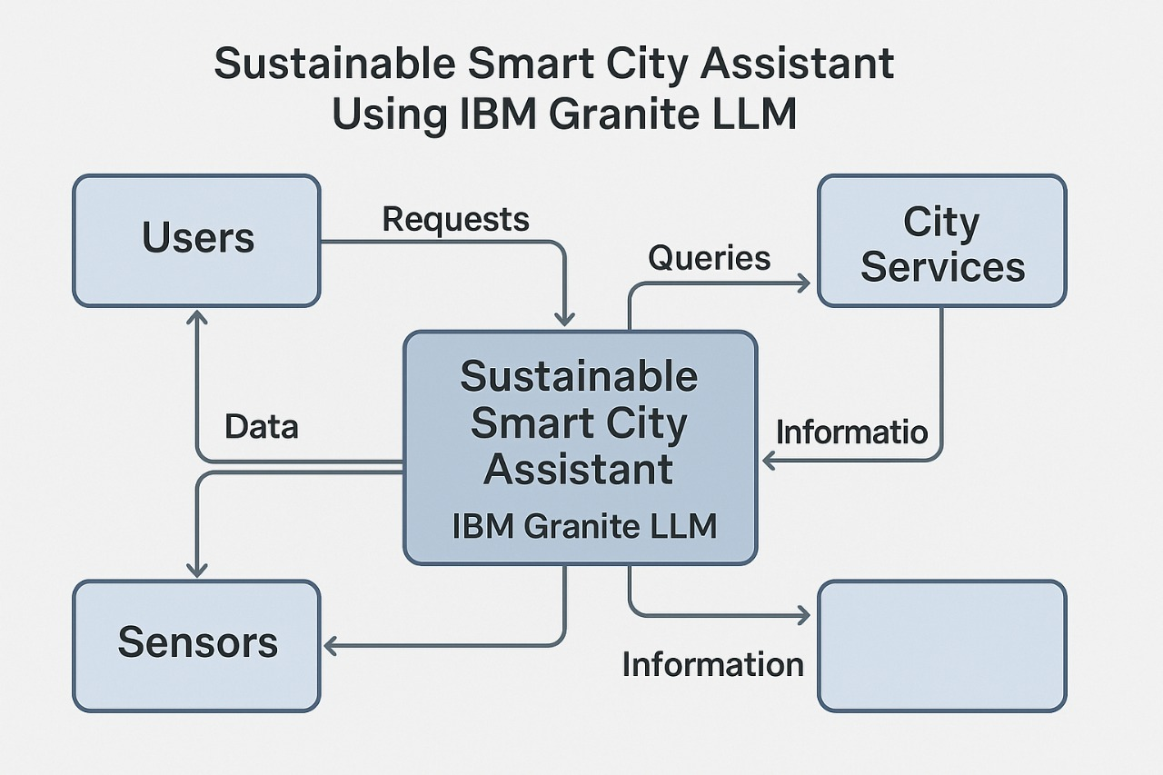

### 

### 

### **3.4 Technology Stack**

* IBM Watsonx Granite LLM
* Pinecone Vector Search
* FastAPI, Streamlit
* Python (Pandas, Scikit-learn, dotenv, pydantic)
* Sentence-transformers, Matplotlib

## **4. PROJECT DESIGN**

### **4.1 Problem-Solution Fit**

Bridges the gap between policy complexity and public understanding while giving administrators a data-driven assistant.

### **4.2 Proposed Solution**

An AI assistant that supports summarization, forecasting, anomaly detection, and eco-awareness via a streamlined dashboard and modular backend.

### **4.3 Solution Architecture**

Componentized backend → FastAPI routers Embedding engine → Pinecone + Sentence Transformers LLM Services → Granite LLM UI Dashboard → Streamlit frontend with sidebar navigation

## 

## 

## 

## 

## 

## 

## **5. PROJECT PLANNING & SCHEDULING**

### **5.1 Project Planning**

* **Phase 1**: Initialization & Environment Setup

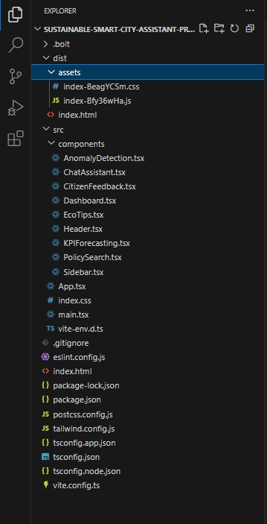

* **Phase 2**: LLM Integration & API Key Management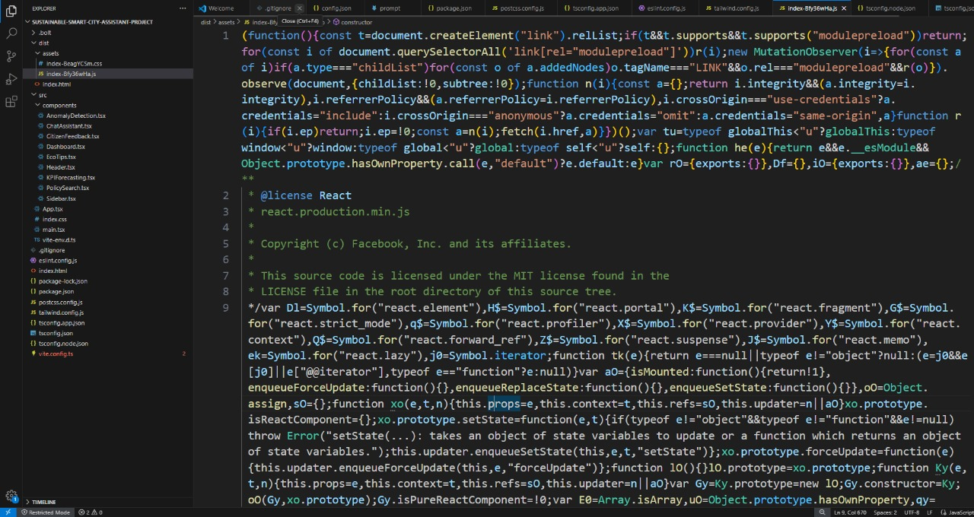
* **Phase 3**: Backend Modular API Development

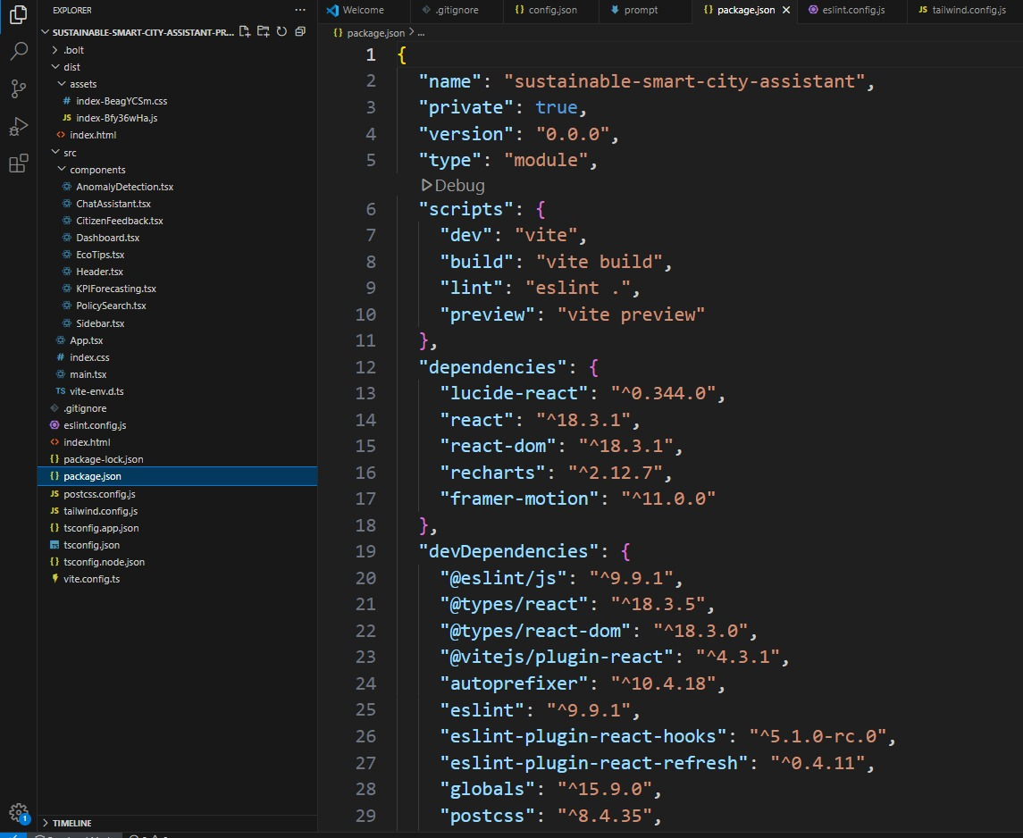

* **Phase 4**: Streamlit UI Creation

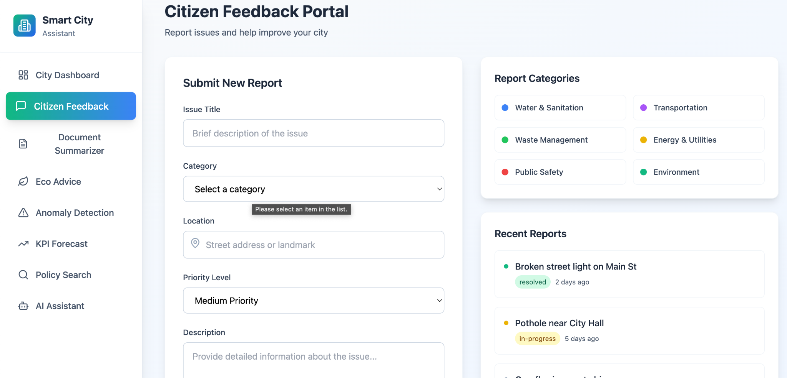

* **Phase 5**: Embedding + Semantic Search

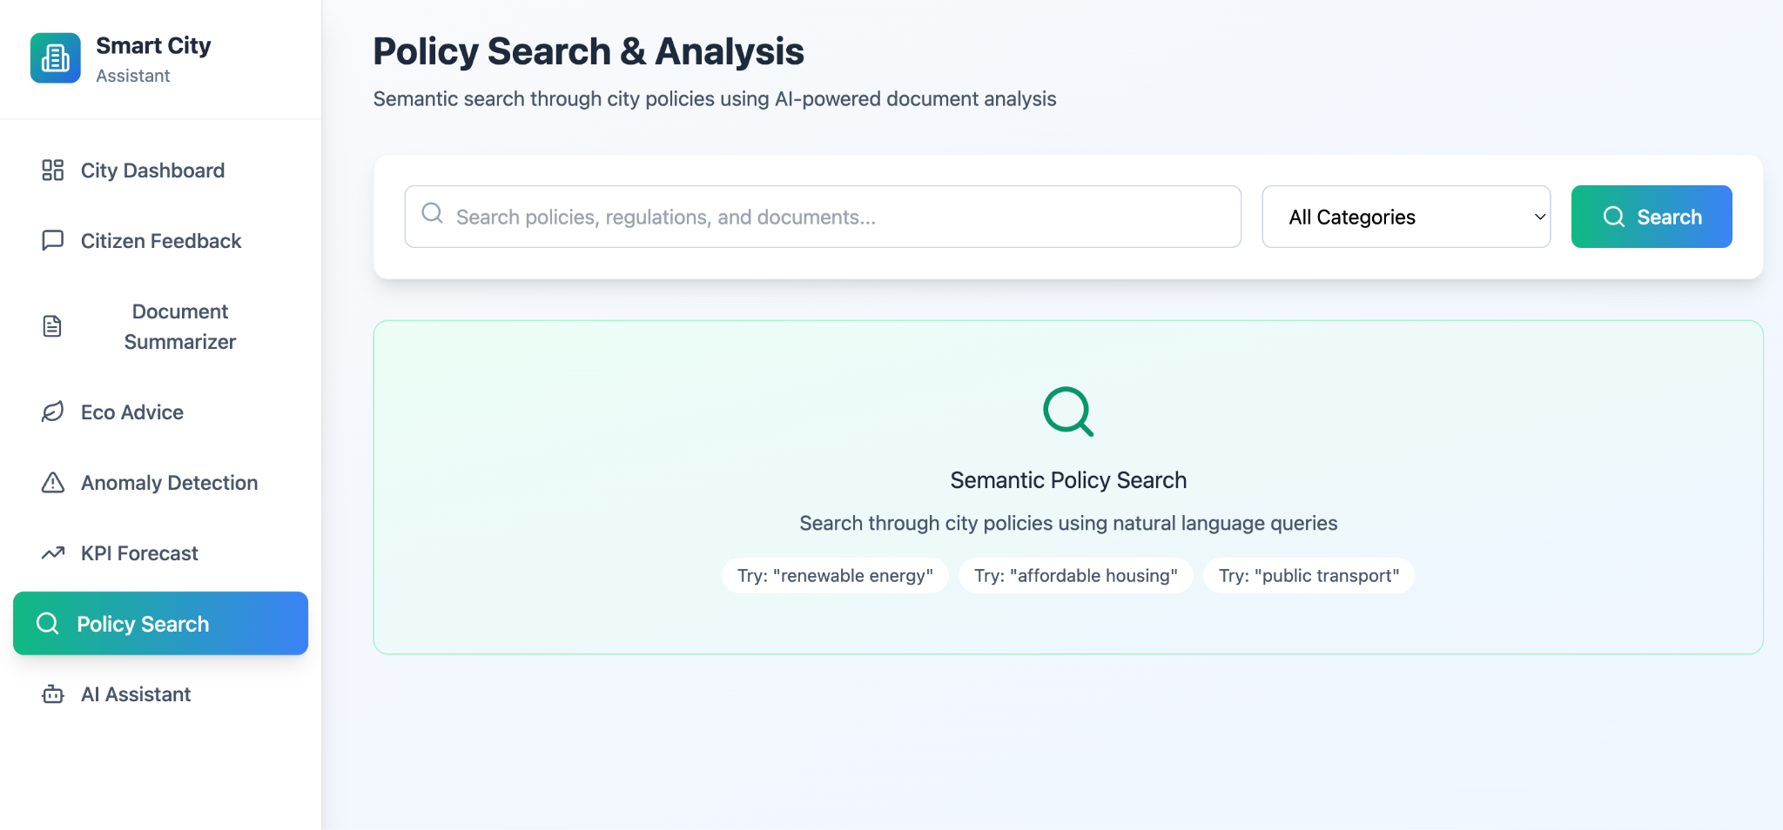

* **Phase 6**: Forecasting + Anomaly Detection

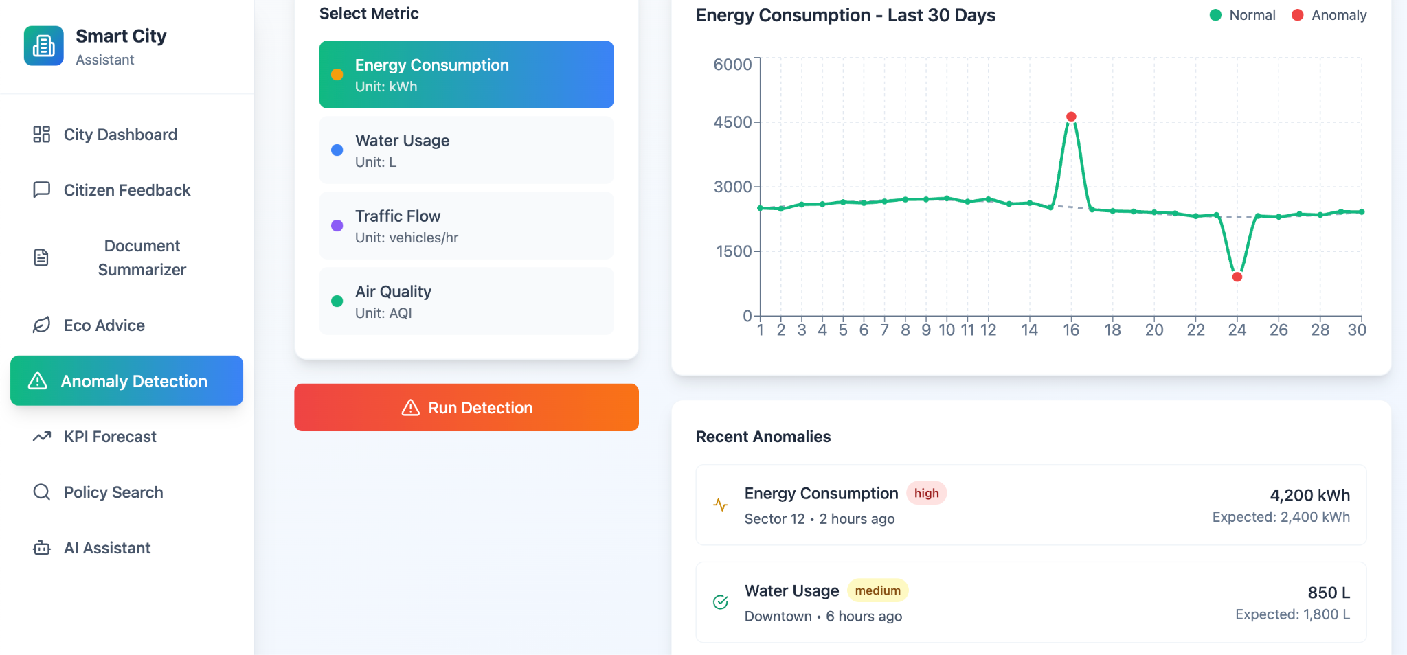

* **Phase 7**: Report Generation + Chat Assistant

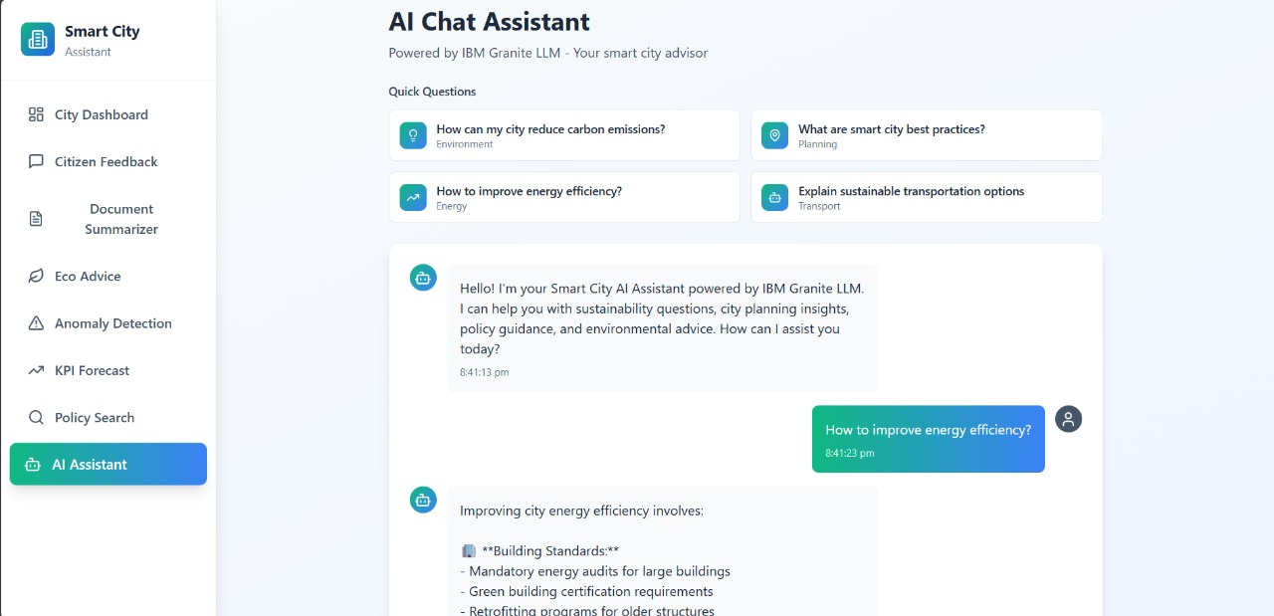

* **Phase 8**: Final Integration & Testing

## **6. FUNCTIONAL AND PERFORMANCE TESTING**

### **6.1 Performance Testing**

* All API endpoints tested using Swagger UI
* Stress-tested document summarization and semantic search
* Load-tested KPI forecasting and anomaly modules with large CSVs

## **7. RESULTS**

### **7.1 Output Screenshots**

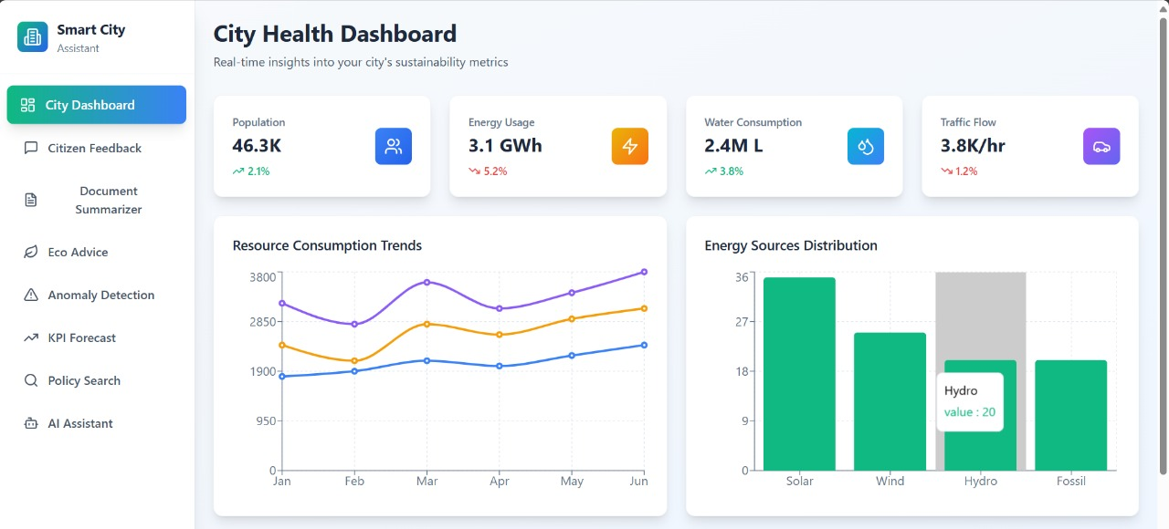

## **8. ADVANTAGES & DISADVANTAGES**

**Advantages:**

* Modular and scalable
* Citizen-centric design
* Real-time forecasting and anomaly detection
* Leverages trusted LLM (Granite) and semantic search (Pinecone)

**Disadvantages:**

* API keys dependency
* Initial setup complexity
* Limited offline usability

## **9. CONCLUSION**

The Sustainable Smart City Assistant demonstrates how AI can integrate urban data, promote transparency, and foster responsible civic participation. It sets a foundation for data-driven smart governance and scalable public services.

## **10. FUTURE SCOPE**

* Voice-enabled assistant for visually impaired users
* Integration with IoT sensors for real-time KPI updates
* Multilingual chat support
* Deployment on cloud platforms for wider reach

## **11. APPENDIX**

**GitHub_Repository_Link** : https://github.com/pinapothu-nani/Sustainable-Smart-City-Assistant-Using-Ibm-Granite-Lim